Qlik APIs, what are them and how to use them in extensions.

For Qlik 2.2, there are 12 APIs available for extension.

https://help.qlik.com/en-US/sense-developer/3.0/Content/APIs-and-SDKs.htm

|  |  |  |  |
| --- | --- | --- | --- |
| Name | Description | Method of access from root API |  |
| [Engine API](https://help.qlik.com/en-US/sense-developer/3.0/Subsystems/EngineAPI/Content/introducing-engine-API.htm) | Engine API is a Web Socket protocol that uses JSON to pass information between the Qlik Sense engine and the clients. | Web socket library | Web socket protocol |
| [Extension API](https://help.qlik.com/en-US/sense-developer/3.0/Subsystems/APIs/Content/extensions-api-reference.htm) | Paint method  selectValues method  snapshot property  initialProperties property  export property  exportData property | Methods and properties are redefined in extension. | JavaScript library |
| [Backend API](https://help.qlik.com/en-US/sense-developer/3.0/Subsystems/APIs/Content/backend-api-reference.htm) | Communicating with the Qlik engine. Provides helper functions for Qlik engine calls and access to Qlik engine data. | this.backendApi | JavaScript library |
| [Root API](https://help.qlik.com/en-US/sense-developer/3.0/Subsystems/APIs/Content/MashupAPI/qlik-interface-interface.htm) | External interface to Qlik Sense | Including “qlik” dependency in extension | JavaScript library |
| [App API](https://help.qlik.com/en-US/sense-developer/3.0/Subsystems/APIs/Content/MashupAPI/qlik-app-interface.htm) | Interface to a Qlik Sense app and contains methods for app level commands | Access through root API -> App API  Example: Qlik.currApp | JavaScript library |
| [Bookmark API](https://help.qlik.com/en-US/sense-developer/3.0/Subsystems/APIs/Content/MashupAPI/qlik-bookmark-interface.htm) | External interface to the bookmarks in a Qlik Sense app. | Access through root API -> App API -> bookmark API  Example qlik.currApp.bookmark | JavaScript library |
| [Field API](https://help.qlik.com/en-US/sense-developer/3.0/Subsystems/APIs/Content/MashupAPI/qlik-field-interface.htm) | Entry point to the Field API. It returns a QField object with methods and properties that can be used to manipulate the field. | Access through root API -> App API -> field API  Example qlik.currApp.field | JavaScript library |
| [Global API](https://help.qlik.com/en-US/sense-developer/3.0/Subsystems/APIs/Content/MashupAPI/qlik-global-interface.htm) | external interface to Qlik Global | Access through root API -> global API  Example qlik.global | JavaScript library |
| [Table API](https://help.qlik.com/en-US/sense-developer/3.0/Subsystems/APIs/Content/TableAPI/qlik-table-interface.htm) | The Table API allow developers to work with tabular data returned from the Qlik engine without having deeper knowledge of internal constructs, like for example a Hypercube.  The table object will be updated when selection state changes. Notification is sent when data is available and will be triggered after each update. To receive notification bind a listener on OnData of QTable instance. | Access through root API -> App API -> tableAPI  Example  qlik.currApp.createTable()  Access through rootAPI -> table API  Exmple qlik.table(this) | JavaScript library |
| [Navigation API](https://help.qlik.com/en-US/sense-developer/3.0/Subsystems/APIs/Content/NavigationAPI/NavigationAPI.htm) | allows you to navigate within a Qlik Sense app.  Change mode(analysis/edit); change sheet; change story | Access through root API -> navigation API  Example qlik.navigation | JavaScript library |
| [Selection API](https://help.qlik.com/en-US/sense-developer/3.0/Subsystems/APIs/Content/SelectionAPI/qlik-selectionState-interface.htm) | The SelectionState API allows developers to work with selection state data returned from the Qlik engine without having deeper knowledge of internal constructs. | Access through root API -> App API -> selection API  Example qlik.currApp.selectionState(state) | JavaScript library |
| [Variable API](https://help.qlik.com/en-US/sense-developer/3.0/Subsystems/APIs/Content/MashupAPI/qlik-variable-interface.htm) | the external interface to Qlik Sense variables | Access through root API -> App API -> variable API  Example qlik.currApp.variable | JavaScript library |

To summarize, there are three main entry point to access the APIs in extension,

“This” keyword (the extension)

Extension level operation; Data manipulation, selection etc.

1. Backend API

Root API (“qlik” dependency)

Global level operation including getting reference to current app

1. App API
2. Global API
3. Navigation API
4. Table API

App API (example: Root API-> currApp)

Application level operation.

1. Bookmark API
2. Field API
3. Table API
4. Selection API
5. Variable API

Function and properties in Root API:

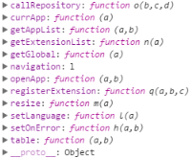

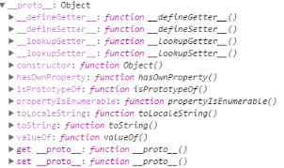

Function and properties in App API

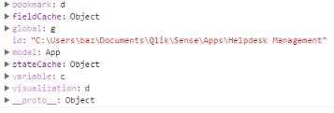

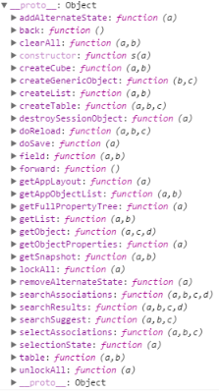

Function and properties in the extension (This)

